**Create the following tables with the given structure.**

**EMPLOYEES TABLE**

**NAME NULL? TYPE**

**Employee_id Not null Number(6)**

**First_Name Varchar(20)**

**Last_Name Not null Varchar(25)**

**Email Not null Varchar(25)**

**Phone_Number Varchar(20)**

**Hire_date Not null Date**

**Job_id Not null Varchar(10)**

**Salary Number(8,2)**

**Commission_pct Number(2,2)**

**Manager_id Number(6)**

**Department_id Number(4)**

**(a) Find out the employee id, names, salaries of all the employees**

**SELECT Employee_id, First_Name, Last_Name, Salary FROM EMPLOYEE;**

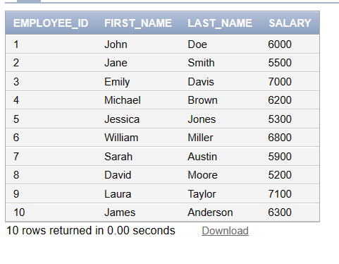

**(b) List out the employees who works under manager 100**

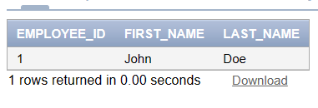

**(c) Find the names of the employees who have a salary greater than or equal to 4800**

**SELECT First_Name, Last_Name FROM EMPLOYEE WHERE Salary >= 4800;**

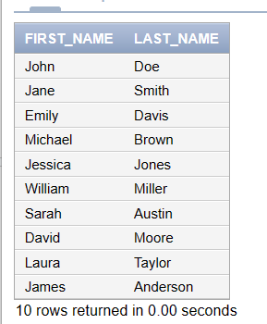

**(d) List out the employees whose last name is ̳AUSTIN‘**

**SELECT First_Name, Last_Name FROM EMPLOYEE WHERE Last_Name = 'AUSTIN';**

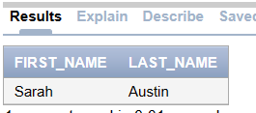

**(e) Find the names of the employees who works in departments 30,70 and 80**

**SELECT First_Name, Last_Name FROM EMPLOYEE WHERE Department_id IN (30, 70, 80);**

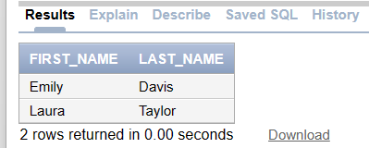

**(f ) Display the unique Manager_Id.**

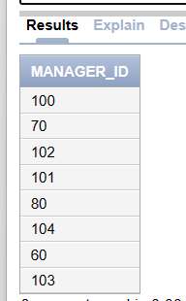

**Create an Emp table with the following fields: (EmpNo, EmpName, Job,Basic, DA, HRA,PF,**

**GrossPay, NetPay) (Calculate DA as 30% of Basic and HRA as 40% of Basic)**

**(a) Insert Five Records and calculate GrossPay and NetPay.**

**(b) Display the employees whose Basic is lowest in each department.**

**(c) If Net Pay is less than**

**DEPARTMENT TABLE**

**NAME NULL? TYPE**

**Dept_id Not null Number(6)**

**Dept_name Not null Varchar(20)**

**Manager_id Number(6)**

**Location_id Number(4)**

**JOB_GRADE TABLE**

**NAME NULL? TYPE**

**Grade_level Varchar(2)**

**Lowest_sal Number**

**Highest_sal Number**

**LOCATION TABLE**

**NAME NULL? TYPE**

**Location_id Not null Number(4)**

**St_addr Varchar(40)**

**Postal_code Varchar(12)**

**City Not null Varchar(30)**

**State_province Varchar(25)**

**Country_id Char(2)**

**1. Create the DEPT table based on the DEPARTMENT following the table instance chart**

**below. Confirm that the table is created.**

**Column name ID NAME**

**Key Type**

**Nulls/Unique**

**FK table**

**FK column**

**Data Type Number Varchar2**

**Length 7 25**

**2. Create the EMP table based on the following instance chart. Confirm that the table is**

**created.**

**Column name ID LAST_NAME FIRST_NAME DEPT_ID**

**Key Type**

**Nulls/Unique**

**FK table**

**FK column**

**Data Type Number Varchar2 Varchar2 Number**

**Length 7 25 25 7**

**3 Modify the EMP table to allow for longer employee last names. Confirm the**

**modification.(Hint: Increase the size to 50)**

**4 Create the EMPLOYEES2 table based on the structure of EMPLOYEES table. Include**

**Only the Employee_id, First_name, Last_name, Salary and Dept_id coloumns. Name the**

**columns Id, First_name, Last_name, salary and Dept_id respectively.**

**5 Drop the EMP table.**

**6 Rename the EMPLOYEES2 table as EMP.**

**7 Add a comment on DEPT and EMP tables. Confirm the modification by describing the**

**table.**

**8 Drop the First_name column from the EMP table and confirm it.**